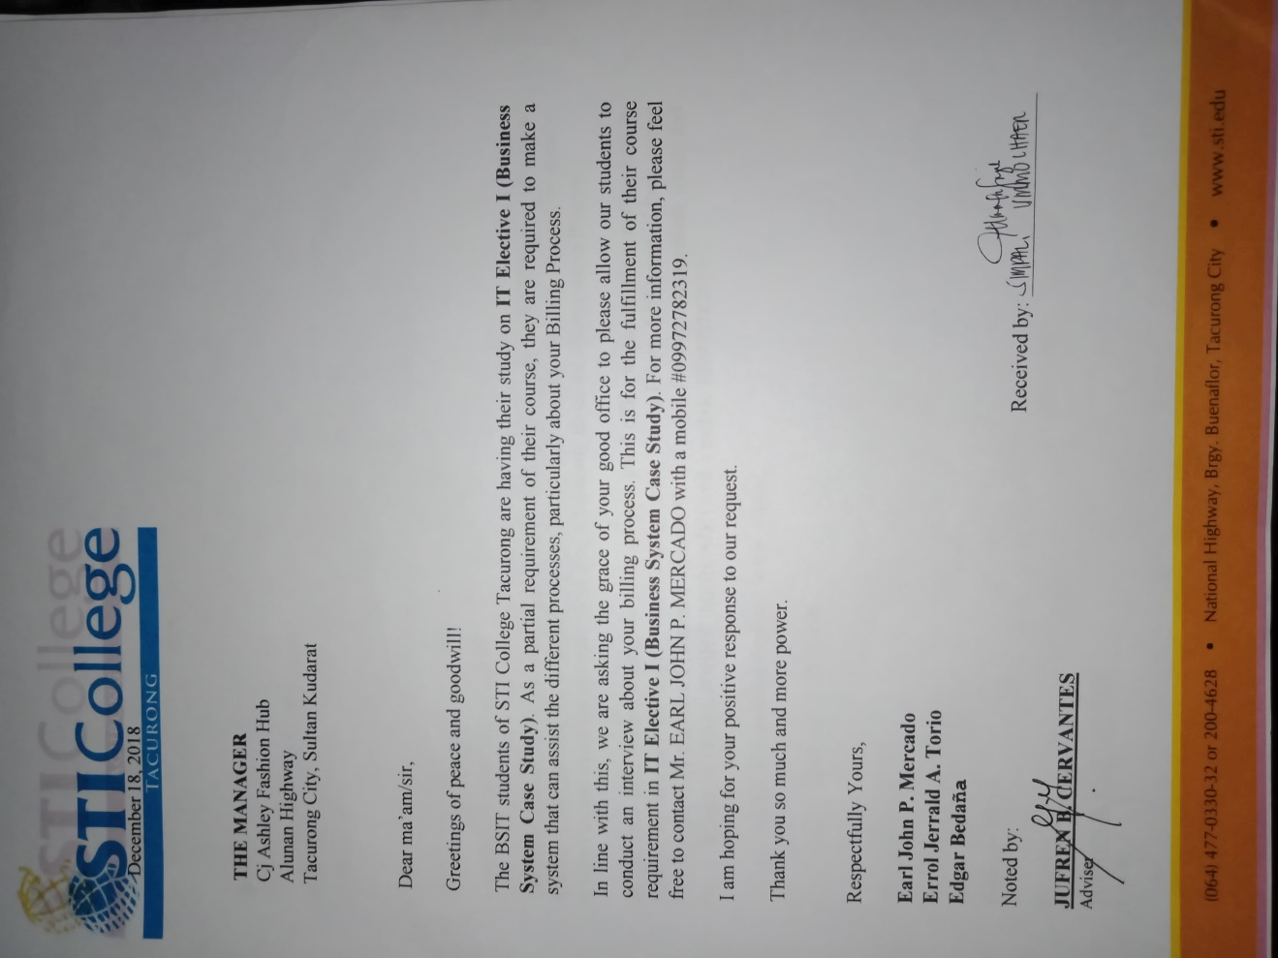**APPENDIX A: RAW DATA**

**INTERVIEW LETTER**

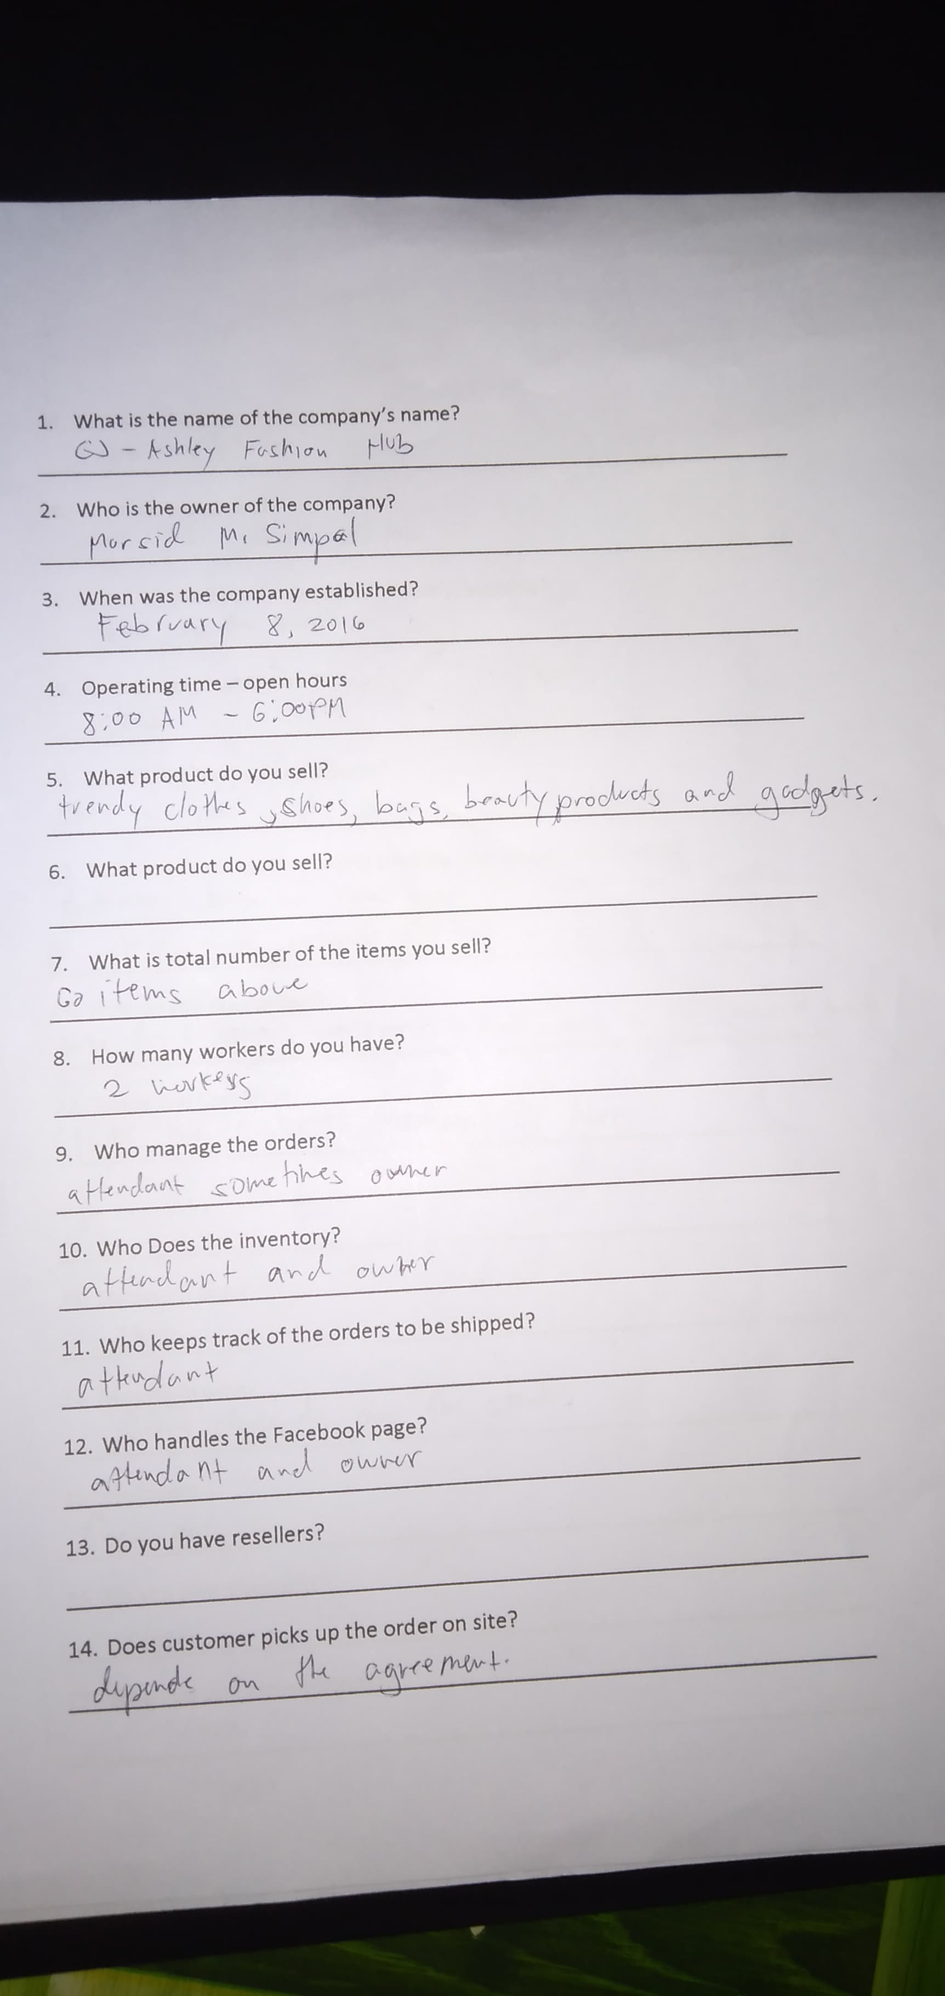

**QUESTION**A**IRE PAGE -1**

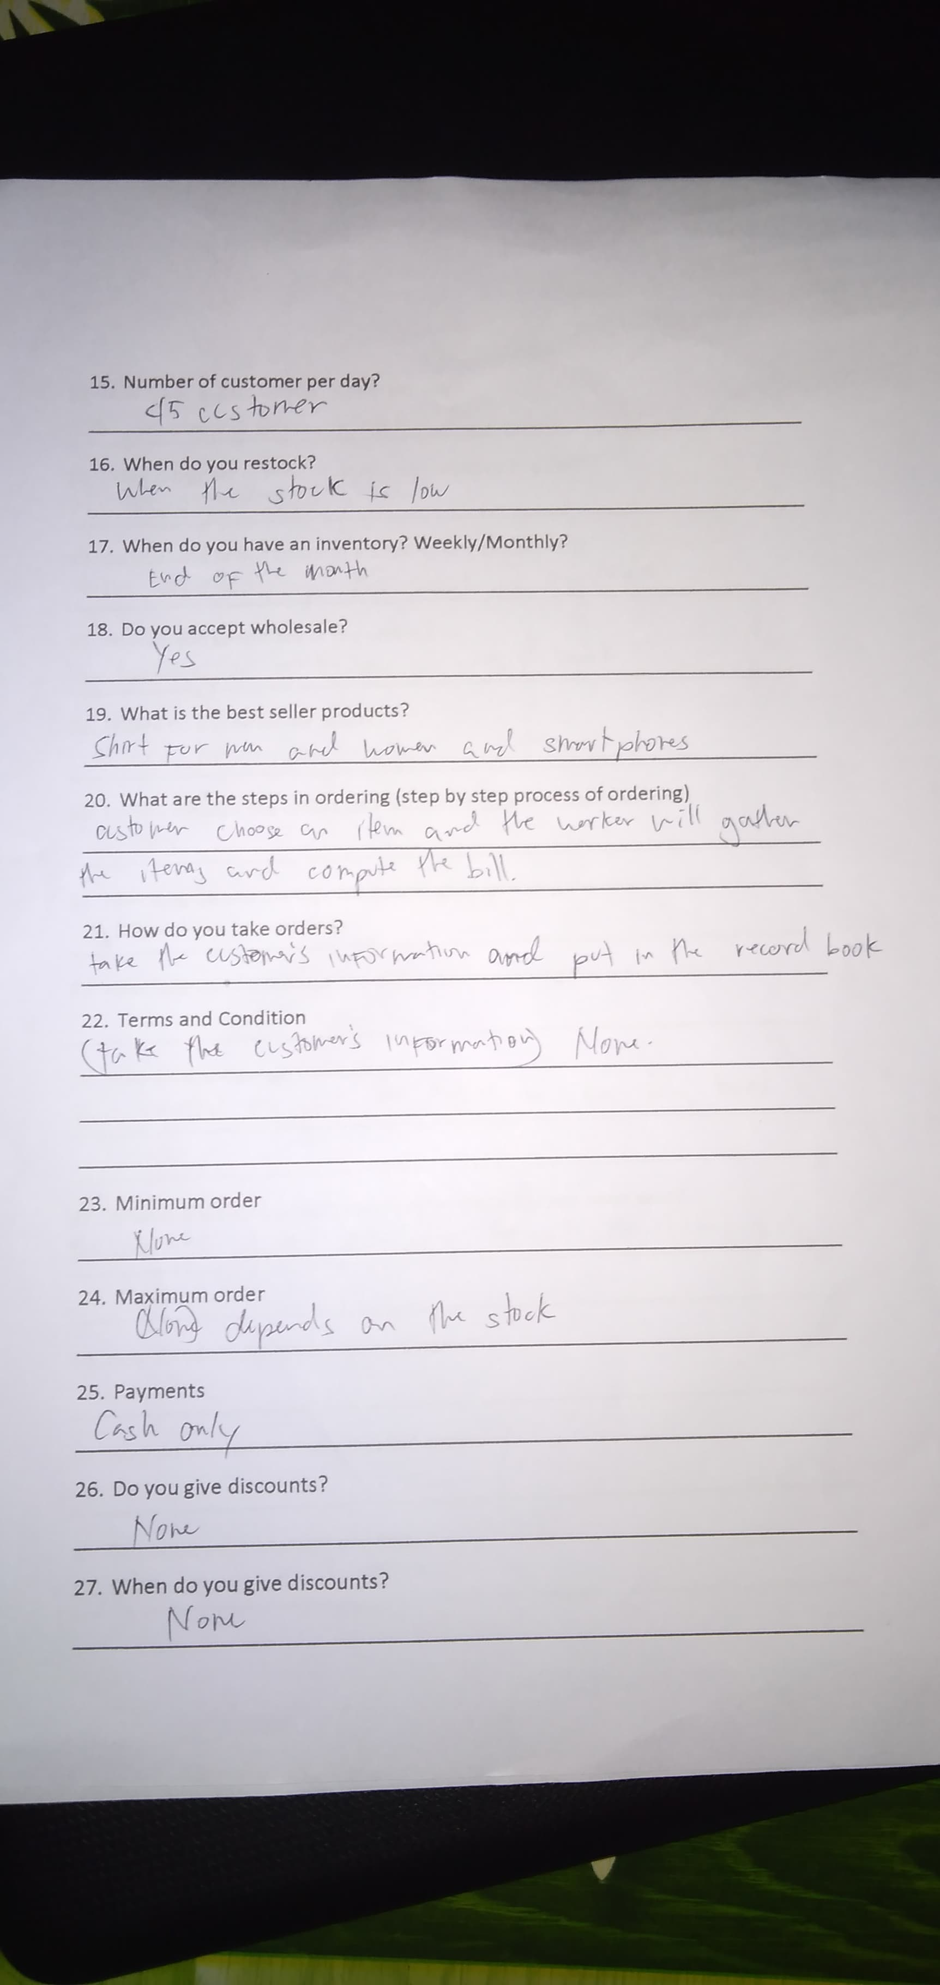

**QUESTIONAIRE PAGE-2**

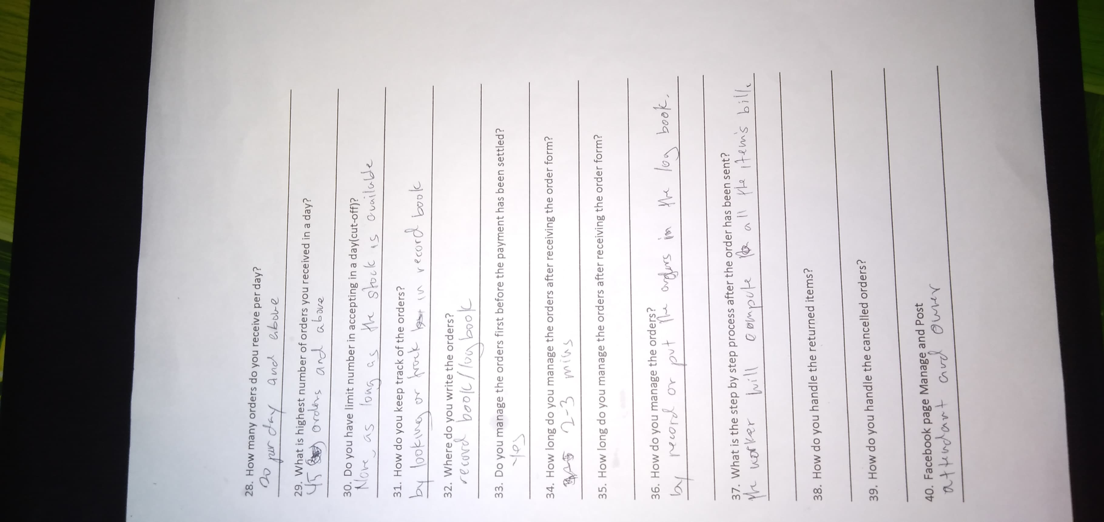

**QUESTIONAIRE PAGE - 3**



**CJ-ASHLEY FASHION HUB LOGO**

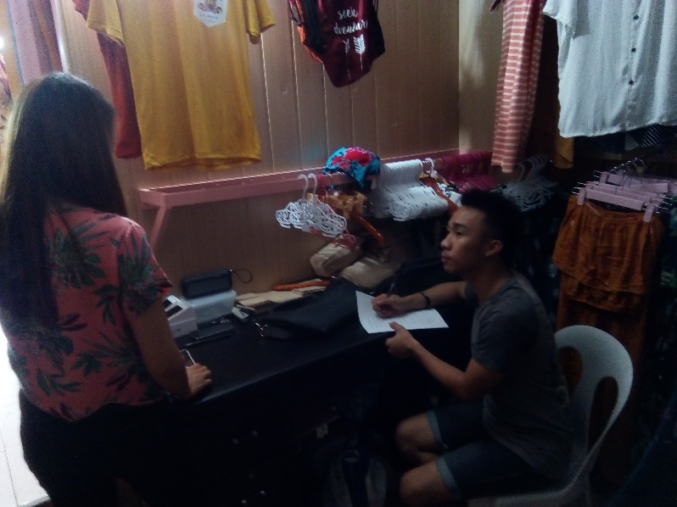

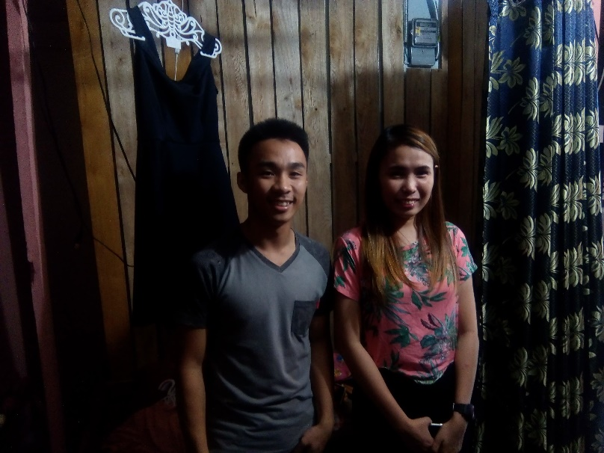

**PICTURES DURING INTERVIEW**